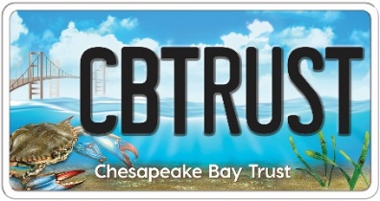
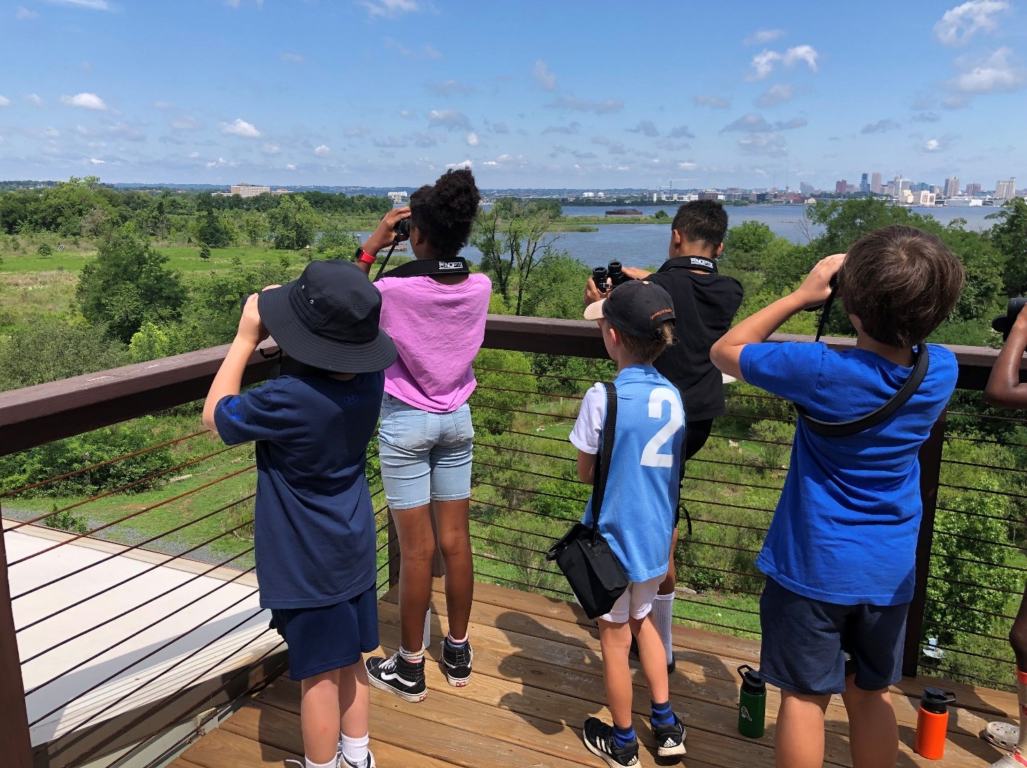

Youth Environmental Education

Grant Program
FY27 Request for Proposals

Chesapeake Bay Trust | 108 Severn Avenue, Annapolis, MD 21403
(410) 974 - 2941 | www.cbtrust.org

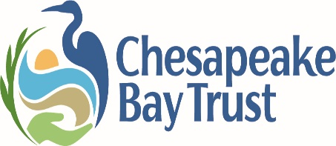

Introduction and Program Goals
At A Glance
Program Summary:
The Youth Environmental Education Grant Program is designed to engage youth and students in outdoor education activities that raise public awareness and participation in the restoration and protection of the Chesapeake and coastal Bays and their rivers.
Deadline:
Thursday, July 9th, 2026 at 4:00 PM EST
Eligible Project Locations:
This program funds throughout the state of Maryland and the Chesapeake Bay watershed portions of D.C., Delaware, Pennsylvania, Virginia, and West Virginia.
Request Amounts:
Applicants can request funds from one of the following tracks:
- Track 1: Out-of-School Outdoor Investigations for Youth Provided by Community-Based Organizations (up to $10,000)
- Track 2: Outdoor Classroom, School-Yard Habitat, or Community-Based Improvement Requests (up to $10,000)
- Track 3: Professional Development for Formal, Non-Formal, and Community Educators (up to $5,000)
- Track 4: In-school MWEEs for Pre-K-12 Students (up to $5,000)
How to Apply:
Follow the instructions online at https://cbtrust.org/grants/youth-environmental-education-grant-program/
Contact:
Jaren Baluyot, Program Officer, jbaluyot@cbtrust.org, 410-974-2941 x 103
This Request for Proposals was released on Thursday, April 30th, 2026
The Chesapeake Bay Trust (Trust) is a nonprofit, grant-making organization dedicated to improving the bays, streams, rivers, forests, parks, and other natural resources of our local systems, from the Chesapeake to the Coastal Bays to the Youghiogheny River. The Trust, supported in large part by Maryland’s Chesapeake Bay License Plate, and partnerships with other regional funders, engages and empowers diverse groups to take actions that enrich natural resources and local communities of the Chesapeake Bay region. Since 1985, the Trust has awarded over $190 million in grants to municipalities, nonprofit organizations, schools, and public agencies throughout the Chesapeake Bay watershed.
The Youth Environmental Education Grant Program is a partnership between the Trust and National Oceanic and Atmospheric Administration (NOAA).
Through this program, the Trust seeks to increase youth knowledge and involvement in the restoration and protection of our region’s natural resources by increasing access to programs that provide robust outdoor environmental education.
The program was established to provide accessible funds to organizations, agencies for youth (generally in the age range of Pre-K to 12th grade), and schools for environmental education and educator support. The program specifically seeks to:
- Educate youth about natural and aquatic resources, their local watersheds, and how they can make a difference in natural resource health,
- Engage communities in education and restoration activities that benefit watershed health,
- Provide environmental education professional development opportunities for formal, non-formal, and community educators,
- Provide Meaningful Watershed Educational Experiences (MWEEs) for students and teachers, and
- Support environmental literacy goals within schools, school systems, and other educational institutions.
The Trust recognizes that application processes can be complicated and time-consuming; the Trust continues to work to simplify our application processes where possible. New applicants, new organizations, small organizations, or any group that is experiencing capacity challenges or other barriers to applying, is eligible to receive guidance on the application process. Please contact the Program Officer, Jaren Baluyot (jbaluyot@cbtrust.org, 410-974-2941 x 103), for assistance.
Applicants are strongly encouraged to contact Trust staff to discuss applications at least two weeks prior to the deadline. The Trust cannot guarantee availability of site visits or project development assistance within two weeks of the deadline.
.

** Applicants interested in small requests (<$5,000) to support community engagement and stewardship projects targeting adult communities should refer to the Community Engagement Mini Grant Program available at https://cbtrust.org/grants/community-engagement/

Eligible Applicants
The Trust welcome requests from the following organizations:
- 501(c)3 Organizations
- Faith Based Organizations
- Community Associations
- Service, Youth, and Civic Groups
- Municipal, County, Regional, State, Federal Public Agencies
- Soil/Water Conservation Districts and/or Resource Conservation and Development Councils
- Forestry Boards
- Public or Independent Higher Education Institutions
  - For Profit organizations are NOT eligible for funding through this program.
For school-based projects: the Trust prefers that the school serve as the lead applicant instead of a partner, however, if a partner does apply, the Trust requires the following:
- The participating school(s) name(s)
- A narrative statement explaining why the partner is applying rather than a school
- Letter(s) of commitment from participating school(s)

Eligible Project Tracks
Project Track 1: Out-of-School Outdoor Investigations for Youth Provided by Community-Based Organizations (requests up to $10,000)
Track 1 requests will engage youth in the local community through outdoor investigations led by established community-based organizations. Youth engaged through this track will be participating in community-based, after-school, weekend, and/or summer programs. If the applicant seeks to engage students in partnership with local schools, please apply to track 4. Track 1 requests, submitted by community-based organizations, will be prioritized through this grant opportunity. Applicants can request funds for project supplies, field trip fees, bus transportation, staff time to support project implementation, and other related costs. Proposals that include the elements below will be prioritized:
- Inclusion of environmental education best practices and alignment with the MWEE framework.
  - The MWEE framework focuses on youth investigating local environmental issues and then taking informed action to address the issues they have identified. This framework has been proven to assist in the delivery of high-quality outdoor education.
  - The MWEE framework was designed with the formal school classroom in mind; however, can be adapted for out-of-school settings to enhance instruction. Proposals that include the four “Essential Elements” of the MWEE in their instruction and adapt the four “Supporting Practices,” where possible, will be prioritized.
  - Applicants are encouraged to review sources for best practices for meaningful outdoor experiences; specifically the “Educator’s Guide to the Meaningful Watershed Educational Experience (MWEE)” and Bay Backpack’s MWEE resources, which have tools and examples for building a successful MWEE.
Project Track 2: Outdoor Classroom, School-Yard Habitat, or Community-Based Improvement Requests (requests up to $10,000)
Track 2 requests will focus on developing outdoor learning space in local communities or on school grounds through the installation of outdoor classrooms, school-yard native habitats (such as a one-time tree planting or pollinator garden planting), or community-based improvement projects. There is a growing body of research that demonstrates the benefits of outdoor learning for mental health, stress reduction, physical health, student engagement, and academic success. Applicants must demonstrate how the projects, during design and construction, as well as in the years after completion, will support high quality instruction for youth. Proposals that include the elements below will be prioritized:
- Demonstration that youth will be involved, through the MWEE framework, in the planning and implementation of the outdoor classroom or habitat,
- Integration of the outdoor classroom in future MWEE or outdoor learning programs,
- For school-based projects: indication that the classroom or habitat will be used for certification or re-certification of Green School/Sustainable School status,
- Creation of outdoor learning environments in areas with limited access to green space, and
- Supporting attachments including: a draft design plan, photos of the site, native plant list if applicable, letter of commitment from landowner and/or school facilities department, and maintenance plan.
- While some contractor fees for implementation may be necessary, projects requesting contractor involvement in lieu of any youth involvement will NOT be prioritized.
Project Track 3: Professional Development for Formal, Non-Formal, and Community Educators (requests up to $5,000):
Track 3 requests will support professional development (PD) experiences for community educators and/or school staff (such as teachers and administrators) to build the understanding of environmental content and competence in inquiry based and investigative instructional techniques. Funding will support professional development for formal, non-formal, and community educators.
- The Trust encourages professional development to be at least 30 hours, including workshops and ongoing support to ensure that participants are successful in using the information gained from the trainings.
- PD trainings must:
  - Support elements of the MWEE model, such as the investigation of a local environmental issue, using the outdoors as a context for learning and instruction, and/or design and implementation of an action project.
  - Include strategies to increase the environmental literacy of the participating educators encouraging them to be environmental role models for their students/youth.
- Successful applicants should provide:
  - The prioritized audience (e.g. subject and grade of educators for school-based PD, roles and titles for community-based PD, etc.) that are anticipated to attend the trainings with an explanation of why the educators were selected, and
  - A draft agenda. The absence of a draft agenda will need to be justified.
    - Agenda must require participants to complete the MWEE 101 Online Course and/or include an overview of the MWEE model to ensure participants are able to use what is learned to design, enhance and/or implement their own MWEE.
- PD Facilitators are encouraged to utilize the Facilitator’s Guide to MWEE Training.
Project Track 4: In-school MWEEs for Pre-K-12 Students (requests up to $5,000):
Track 4 requests will engage students in MWEEs. Pre-K-12 teachers interested in completing a MWEE with their students or non-formal educators interested in completing a MWEE with students through a school-based partnership should apply to track 4. MWEEs are multi-faceted, learner-centered experiences that focus on investigations into local environmental issues that lead to informed action. Applicants are encouraged to review sources for best practices for meaningful outdoor experiences; specifically the “Educator’s Guide to the Meaningful Watershed Educational Experience (MWEE)” and Bay Backpack’s MWEE resources, which have tools and examples for building a successful MWEE. Proposals that meet the elements below will be prioritized:
- Programs should include the four Essential Elements and four Supporting Practices of the MWEE.
- The same group of students should be involved in the entire MWEE experience; therefore, projects should not take place over multiple years unless the same students will be involved through the entire project.
Please note: for all tracks, additional evaluation points (2) will be awarded if project leaders have demonstrated completion of the MWEE 101 Online Course, as outlined in “Evaluation Criteria” below.

Funding Restrictions, Match Requirements, and Timeline
Funding Restrictions: All projects must take place in Maryland or the Chesapeake Bay watershed portions of D.C., Delaware, Pennsylvania, West Virginia, and Virginia. Use this kmz file of the Chesapeake Bay watershed boundary in Google Earth to determine if your project location is eligible, or contact us for assistance.
Match Requirements: Match is required for school-based (Track 4) requests in some cases.
- Non-Title 1 schools or schools with less than 50% of students participating in free and reduced meal programs (FARMs): The Trust funds up to half of outdoor field experience costs, such as program fees, substitute costs, and transportation expenses. However, schools are encouraged to exceed the 50% level of match, if possible, by fully exploring match opportunities prior to submitting a request. In an effort to provide resources for as many students as possible to participate in meaningful watershed experiences, we hope our grantees can leverage as many matching funds and resources as possible.
- Schools running school-wide Title 1 programs, as well as schools with over 50% of students enrolled in FARMs programs, are permitted to request full costs for bay and watershed education related field trips. Match is encouraged, but not required.
Project Timeline: Projects must be completed within 12 months upon receipt of the award. Requests to extend project completion period will be reviewed and considered on a case-by-case basis.

Online Application Submission Instructions
The Trust uses an online system for the application process, and if awarded, project management. To apply for an award, go to the Trust website here: https://cbtrust.org/grants/youth-environmental-education-grant-program/, click on “Get Started” to begin a new application. This will open a new window asking you to log in or create an account on our online system. If you have applied in the past, please use your existing username and password (if you have forgotten either of these use the ‘forgot password’ feature). If you have not used our online system before, click on “New Applicant” and follow the instructions.
By submitting an application to this program, applicants acknowledge that: 1) they are compliant with federal employment and non-discrimination laws and 2) they have not been debarred, convicted, charged or had a civil judgment rendered against them for fraud or related offense by any government agency (federal, state or local) or been terminated for cause or default by any government agency (federal, state, or local). In addition, all final products will be provided to the funding partners for use and distribution at the sole discretion of the funding partners.

Deadline
Applicants must submit applications in the Chesapeake Bay Trust Online System by 4:00 PM EST July 9th, 2026. Late applications will not be accepted, and the online funding opportunity will close automatically and promptly at 4:00 PM EST. Applicants are strongly encouraged to submit at least a few days prior to the deadline given the potential for high website traffic on the due date. The Trust cannot guarantee the availability of technical assistance for our online system on the deadline date.

Application Process and Assistance to Applicants
The Trust uses an online system for the application process and grant management. We are currently transitioning to a new grants management system to improve the applicant and grantee partner experience. As part of this transition, the online application portal for this funding opportunity will open after the release of this RFP. We anticipate the system will be live in June, with the application available for at least one month prior to the July 9th deadline at 4:00 PM EST.
Watch our video on how to apply and how to submit an application using our online system at https://cbtrust.org/grants/.
__________________________Definitions
The Executive Officer is the individual that oversees the organization (e.g., Executive Director, Chief Executive Officer, Mayor, President or Vice President, Principal (for schools), etc.) and has the authority to sign/execute award agreements on behalf of the organization. The Executive Officer information is tied directly to all the organization’s applications and should not vary from application to application. If the Executive Officer could be listed as the Project Leader in a future proposal, we recommend listing a Board Member or other higher-ranking position of the organization as the Executive Officer in order to reduce the variation in the Executive Officer across applications.

The Project Leader is the individual will be responsible for all project coordination and correspondence with the Trust for the duration of the project. The email address entered here MUST be the same as the email address you used to log in to the online system. The Project Leader is the primary point of contact for the application, and the email address used to submit the application via the online system must be that of the Project Leader. Applications in which the email address associated with the Project Leader in the applicant information tab of the online opportunity does not match the email address used to submit the application will not be considered for funding. The Trust cannot conduct any official correspondence with contractors or other project partners. If at any time the Project Leader cannot continue in the position, the organization must contact the Trust and assign a new qualified Project Leader.

In the meantime, applicants are encouraged to review this RFP closely and begin preparing responses to the Narrative Questions, which are linked below the RFP on our website and may be completed in advance. A PDF mockup of the online application will be posted on the Trust’s website shortly.
To apply when the system opens, visit https://cbtrust.org/grants/youth-environmental-education-grant-program/ and click “Get Started!

Evaluation Criteria
Track 1 & 4 - Out-of-School Outdoor Investigations for Youth & In-school MWEE for Pre-K-12 Students
- Completeness of the MWEE (1-20): Are the essential elements of a MWEE present and robust?
- Supporting Practices (1-20): Have supporting practices of the MWEE been adapted and included where feasible (Track 1)? Are the supporting practices of a MWEE present (Track 4)?
- Age-Appropriateness (1-10): The MWEE should grow in complexity and sophistication across ages, starting with educator guided investigation and leading to youth-led inquiry.

Track 2 - Outdoor Classroom, School-Yard Habitat, or Community-Based Improvement Requests
- Technical Soundness (1-15): Projects must be carefully planned, technically sound, and involve the assistance of experts, agencies, or organizations as necessary. The applicant must provide information about all technical assistance received and project partners involved in the design and implementation of the projects.
- Connection to instruction (1-15): Are youth/students involved in the planning and design of the outdoor classroom or habitat using the MWEE model?
- Future MWEE instruction (1-15): Has the applicant demonstrated that the outdoor classroom or habitat will be used in future years for MWEE instruction?
- Green School certification (1-5): If applicable, will the project assist the school in Green School/Sustainable School (or equivalent) re-certification or certification?

Track 3 - Professional Development for Formal, Non-Formal, and Community Educators
- Soundness of Plan (1-20): Does the length of training ensure educator success? Will educators be supported before, during, and after the training? Is the draft agenda appropriate? The Trust encourages professional development to be at least 30 hours, including workshops and ongoing support to ensure that participants are successful in using the information gained from the trainings.
- Support of the MWEE (1-15): Does the work support elements of the MWEE model as a context for learning, and/or design and implementation of an action project? Does the agenda require participants to complete the MWEE 101 Online Course and/or include an overview of the MWEE model to ensure participants are able to use what is learned to design, enhance and/or implement their own MWEE?
- Increase in Environmental Literacy (1-15): Will the environmental literacy of the participating educators be increased, encouraging them to be environmental role models for their students/youth?

Additional Criteria for All Tracks – In addition to the above track-specific criteria, the following criteria will also be used to evaluate all proposals.
- Audience Engaged (1-20): Is the audience engaged have limited access to other environmental education opportunities or green space?
- Budget and Match (1-10): Is the budget reasonable? Match is encouraged in all cases and required in some (see “Funding Restrictions, Match Requirements…” section on page 5). Is match included?
- Timing and Feasibility (1-10): Can the project be accomplished? Are all the same participants involved throughout the entire project? Where relevant, are project partners provided?
- Supporting Documents (1-8): Does the applicant include all required supporting documents? (e.g., native plant list, site plan, photos of site, maintenance plan, letters of commitment, agenda, etc.)
- Demonstration of MWEE 101 Online Course Completion (0-2): Has the applicant submitted a certificate demonstrating completion of the MWEE 101 Online Course by the individual(s) implementing the project, and thus experience in designing and implementing a MWEE?

Application Review Process
All submitted applications are scored by technical experts in the field supported by this RFP and discussed by a review committee. Reviewers score all applications based on the evaluation criteria listed in the “Evaluation Criteria” section above. The funding partners reserve the right to fund projects and budget items that advance their mission and meet specific funding priorities and criteria.
To allow applicants to set expectations prior to investing time in application, the Trust provides historical application approval rates for the same or similar programs: The average approval rate from the last 3 rounds in this grant program is 33.4%, this includes both fully and partially funded applications.

Awards and Notifications
The FY27 Youth Environmental Education Grant Program awards will be announced by August 28th, 2026. Project state dates should be no earlier than September 1st, 2026.
All applicants will receive a letter stating the funding partnership’s decision. An application may be declined, partially awarded, or fully awarded. If approved, the Trust will send an award agreement with award conditions and due dates of status, progress, and final reports. The Trust will mail the first award payment to the requesting organization following: satisfaction of any phase 1 payment award contingencies, including upload of the signed award agreement. In some cases, ten percent of the total award will be held until the final report is submitted and approved. In cases where the awardee fails to submit a status report, progress report, or final report by the due date, the Trust reserves the right to terminate the award agreement and require a refund of funds already transferred to the awardee.
When the project is complete, awardees are required to complete final reports that may include but are not limited to submission of all receipts for supplies, invoices for subcontractors/contractors, and copies of timesheets for personnel time used (timesheets must include date, name, time worked per day, and coding to tie the time worked to the award). All financial back-up documentation will be grouped and numbered to correspond to the budget line item reported as spent. Organizations with outstanding final, progress, or status reports will not be awarded additional grants.

