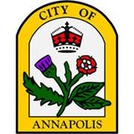
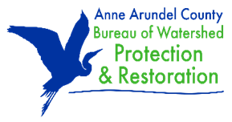
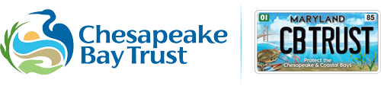
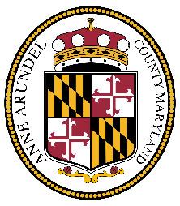

Over $2.3 Million Announced to Support Watershed Restoration and Forestry Projects Throughout Anne Arundel County and the City of Annapolis

FOR IMMEDIATE RELEASE: August 4, 2026

Annapolis, Maryland – Anne Arundel County, the City of Annapolis, and the Chesapeake Bay Trust announce $2,329,583 in funding awarded to fourteen projects to implement cost-effective, community-driven solutions to restore our natural resources. Through the Anne Arundel County Watershed Restoration and Forestry Grant Program (County and City funding administered by the Chesapeake Bay Trust via an open, competitive grant opportunity), local organizations across Annapolis and Anne Arundel County will implement projects to improve water and air quality, increase habitat and tree cover, and reduce flooding and erosion.

"The Chesapeake Bay Trust does an outstanding job of directing these county funds to the community-based organizations that engage residents in the work of protecting our watersheds,” said Anne Arundel County Executive Steuart Pittman. "We are on the path to Bay restoration."

The Anne Arundel County Watershed Restoration and Forestry Grant Program protects and restores the health of local waterways and landscapes throughout the County and the City of Annapolis by relying on the desire of everyday people to make a difference in our communities. Projects are proposed and led by community organizations such as local nonprofits; service, youth and civic groups; faith-based organizations; and community associations and homeowners’ associations. The program supports the planning, designing, and implementation of local projects that improve water quality, restore streams and habitats, protect and expand forests, and increase tree canopy. To be considered for funding, projects must be based in Anne Arundel County, including the City of Annapolis. Applicants were also encouraged to engage at least one partner that represents a stakeholder group based in the County.
The City of Annapolis used this grant program mechanism to support preservation of existing forest within the city limits, allocating $45,000 for the permanent protection, invasive species management, and reforestation of 3.25 acres of woodland forest at St. Luke’s Church.
“Annapolis is known for its connection to the water, but that connection requires active and consistent stewardship," said Annapolis Mayor Jared Littmann. "Through this program, we are investing in Annapolis neighborhoods to problem-solve for future generations. These projects include flood mitigation, stream restoration, and protection of local ecosystems, all of which improve the quality of life for Annapolis residents."
The nonprofit Chesapeake Bay Trust, known by most as the entity that manages funds from the Protect the Chesapeake & Coastal Bays vehicle license plates, specializes in empowering people and communities to lead their own projects to beautify their neighborhoods while treating stormwater at the same time. This type of stewardship has been shown to lead to higher sustainability of projects, and therefore longer-term benefits, and as a result many local jurisdictions partner with the Bay Trust.
“The Chesapeake Bay Trust for decades has helped communities, local governments, and our natural resources in a win-win-win scenario,” said Dr. Jana Davis, president of the Chesapeake Bay Trust. “We’re proud to support these 14 new projects that are designed and led by local communities promoting the health of our neighborhoods and natural resources for generations.”
The Anne Arundel County Watershed Restoration and Forestry Grant Program 2026 Awardees:
Scenic Rivers Land Trust: $45,000 for the protection and restoration of 3.25 acres of forest in Annapolis.
Severn River Association: $64,518 for watershed assessment plans for the Redeemer Anglican Church.
Spa Creek Conservancy: $233,014 for stormwater management in Truxtun Cove.
Severn River Association: $149,533 for a rain garden and permeable pavement in Eastport.
Arundel Rivers Federation: $349,948 for stream restoration at Annapolis Waterworks Park.
Arundel Rivers Federation: $33,721 to treat stormwater at Anchor Yacht Basin.
Anne Arundel Watershed Stewards Academy: $24,530 for a rain garden at Prince of Peace Presbyterian Church.
Arundel Rivers Federation: $349,784 for stream restoration in the Church Creek subwatershed.
Anne Arundel Watershed Stewards Academy: $57,500 to enhance wildlife habitat and improve watershed health on 0.88 acres in Davidsonville.
Severn River Association: $87,958 for stormwater management and a living shoreline in the Hollywood on the Severn community.
Severn River Association: $96,018 for stormwater management in the Kensington and Severndale communities.
Alliance for the Chesapeake Bay: $81,865 for five ecological and stormwater restoration projects in the Cape St. Claire community.
Friends of Jug Bay Wetlands Sanctuary: $349,984 for stream restoration implementation at Jug Bay Wetlands Sanctuary.
Scenic Rivers Land Trust: $406,210 for permanent protection of 125.63 acres of forest and 0.88 acres of afforestation in Tracey's Landing.

###

About the Chesapeake Bay Trust
The Chesapeake Bay Trust (www.cbtrust.org) envisions a restored and protected Chesapeake Bay watershed and other natural resources in our area, from the Coastal Bays to the Chesapeake to the Youghiogheny River. Every year, the Trust empowers about 400 groups by providing grants and technical assistance to accomplish environmental education, community outreach, and local watershed restoration projects. The Trust is supported by the sale of the Protect the Chesapeake & Coastal Bays license plate; donations to the Chesapeake Bay and Endangered Species Fund on the Maryland State income tax form; donations made by hunters, fishers, and boaters in the Maryland online natural resource licensing system; donations from individuals and corporations; and partnerships with private foundations and federal, state, and local governments such as Anne Arundel County and the City of Annapolis. The Trust has received the highest rating from Charity Navigator for over two decades: On average, 90 cents of every dollar go to programs.
MEDIA CONTACT:
Celia Parker
Chesapeake Bay Trust
cparker@cbtrust.org
(410) 974-2941 x142

