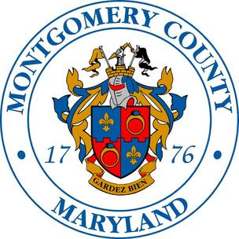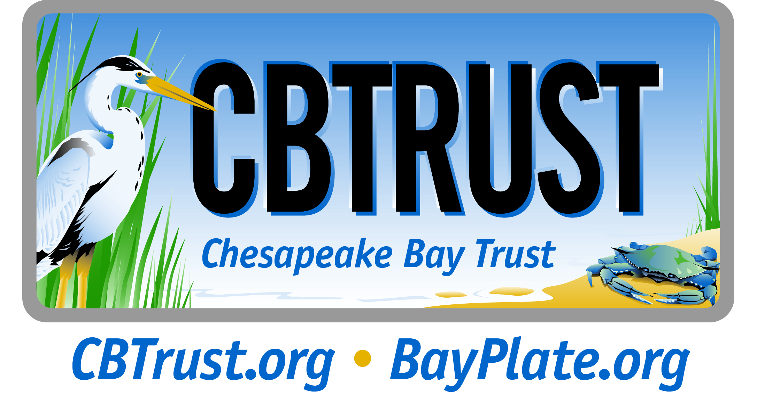

Release Date: September 10, 2014

Chesapeake Bay Trust: Molly Alton Mullins 410-271-3469 mmullins@cbtrust.org
Montgomery County's Public Information Office: Bonnie Ayers, 240-777-6536, Bonnie.Ayers@montgomerycountymd.gov

New Montgomery County Watershed Restoration Grant Program Announced

Annapolis – Montgomery County and the Chesapeake Bay Trust today announced a new grant program to support watershed restoration and outreach throughout the County. The goal of the Montgomery County Watershed Restoration and Outreach program is to reduce stormwater runoff and pollutants through community-based restoration, including RainScapes practices, as well as to implement projects focused on public involvement through education, outreach and stewardship.

“This innovative program encourages on-the-ground restoration projects as well as outreach and engagement activities that reduce stormflow and pollutants and engage Montgomery County residents,” said Fariba Kassiri, acting director of Montgomery County’s Department of Environmental Protection. “We are pleased to work with the Chesapeake Bay Trust to administer these grants that will help restore and protect the local rivers and streams in the County.”

Non-profit organizations, including local watershed groups, community associations, service and civic groups, and faith-based organizations, are eligible to apply for funding. Grants up to $50,000 are available (with larger awards possible with prior approval), and all projects must take place in Montgomery County, outside the municipalities of Rockville, Gaithersburg and Takoma Park.

“The Chesapeake Bay Trust administers hundreds of grants each year that engage individuals in projects and programs that support watershed restoration and the improvement of local streams and rivers,” said Jana Davis, executive director of the Chesapeake Bay Trust. “This partnership is an excellent opportunity to educate local residents about watershed restoration opportunities while also providing valuable resources to implement low impact development stormwater techniques.”

Funding is available for three types of efforts: public outreach and stewardship projects, community-based stormwater runoff and water quality improvement practices, and RainScapes Neighborhood projects. Suggested projects include small-scale stormwater practice installations such as those supported through the RainScapes program (including rain gardens, native trees and conservation landscaping); bioretention cells, streamside forest buffers and green roofs; pet waste management and litter prevention and reduction efforts. Before applying, interested persons should contact the Chesapeake Bay Trust to discuss project ideas and partnerships.

“Montgomery County has a responsibility to meet regulatory watershed restoration and water quality improvement goals. However, significant effort is needed from individuals and community-based groups as well, since the amount of privately owned land far exceeds the amount of County-owned land,” said Kassiri. “We look forward to working with Montgomery County residents and the Chesapeake Bay Trust as we all do our part to restore and protect our vital natural resources.”

Applications are due on December 4, 2014 by 5 p.m. To learn more and review the request for proposals, visit www.cbtrust.org/montcountywatershedgrant or contact Sadie Drescher at 410-974-2941, x103.

About Montgomery County’s Department of Environmental Protection
The mission of the Department of Environmental Protection is to: 1) Protect and enhance the quality of life in our community through the conservation, preservation, and restoration of our environment, guided by the principles of science, resource management, sustainability, and stewardship. 2) Provide solid waste management services, including recycling, in an environmentally progressive and economically sound manner.

About the Chesapeake Bay Trust

The Chesapeake Bay Trust is a nonprofit, grant-making organization dedicated to improving the Chesapeake Bay and its rivers through environmental education, community outreach, and local watershed restoration. Since 1985, the Trust has awarded $65 million in grants and engaged hundreds of thousands of citizen stewards in projects that have a measurable impact on the Chesapeake Bay and its tributaries. The Trust is supported by the sale of the Maryland Treasure the Chesapeake license plate, donations to the Chesapeake Bay and Endangered Species Fund on the Maryland State income tax form, donations from individuals and corporations, and partnerships with private foundations and federal and state agencies.

# # #
Media Contact: Bonnie Ayers, 240-777-6536

Office of Public Information
Montgomery County, Maryland
240-777-6536

