Keep Maryland Beautiful:

Track 1, Community Stewardship

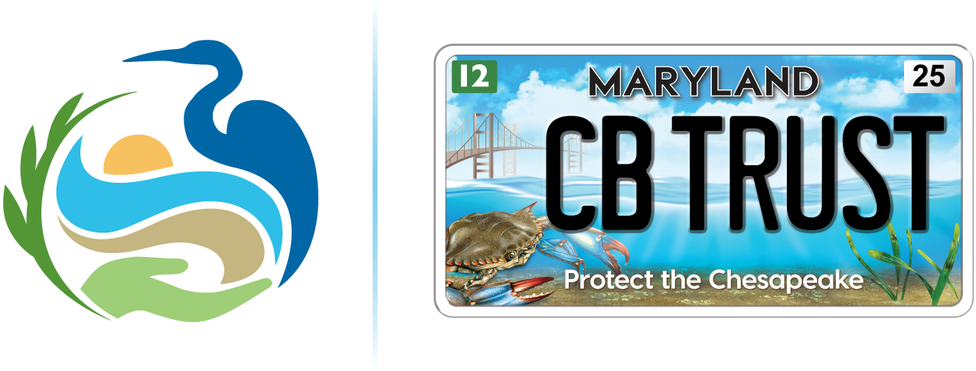

Final Report Narrative Questions

www.cbtrust.org / 410-974-2941

Complete the final report narrative questions below. After completing your narrative questions, save this document on your computer and then submit the document via your Chesapeake Bay Trust Online System account. You can access your account using this link https://www.GrantRequest.com/SID_1520.

- Awardee Information

Organization Name:
Project Leader:
Award Number:
Date:

- Project summary
- Describe the program and results achieved.
- Describe any public involvement in the project that has occurred, including the specific roles of volunteers in project activities.
- In light of the Trust’s commitment to the advancement of diversity in its grantmaking, please provide demographic information regarding the community or population benefiting from or served by the project and the demographic information regarding the project participants.
- Describe how the population and/or the community were involved in the planning, development, and implementation of the proposed project.
- Describe how the project complemented other water quality related environmental activities in your community.
- Describe any outreach or educational activities (e.g. training, brochures, press releases, or public events) related to the project that has occurred. Please submit digital images, newsletter articles, or press clippings to supplement your written description.

- Assessment and Results (only applicable to water quality monitoring projects)
  - Describe project assessment activities including any monitoring and maintenance that has taken place during the reporting period and/or procedures. Please submit examples of results from project assessment activities with this report.

4. Project evaluation and lessons learned
- Discuss the project’s goal(s) and evaluation(s). Include how the project measured success to meet the goal(s) and to report the outcome(s) as project deliverables.
- Discuss the greatest successes.
- Discuss the greatest challenges, including the lessons learned, and potential roadblocks to future progress.

- Transferability and sustainability
- Was the project or will the project be transferred to other locations?
- How will these efforts be sustained in the future?

- Final Project Deliverables
- Provide all final products (e.g., educational documents, publications, pamphlets, etc.) and any other additional deliverables as outlined in your grant application and modified through any contingencies.

Budget Expenses: Submit your Expenses Worksheet of the Financial Management Spreadsheet used during the application phase in the online grant management system to report expenses. Any unused funds must be refunded to the Trust. For the final report budget submission:
- Provide the required final report budget form spreadsheet that reflects the approved budget items.
- Provide a complete accounting of expenditures to date; if required in your award agreement please also include all invoices, receipts, and an accounting of personnel costs, such as copies of timesheets (if personnel time was used) and group all receipts, invoices, and copies of timesheets (if personnel time was used) by budget category type (e.g., supplies, contractual, travel, etc.) and number each item to correspond with specific budget line item expenditures reported.

Review the “Expenses Instructions” worksheet in the Financial Management Spreadsheet for details on how to submit your expenses. In addition, the Financial Management Spreadsheet webinar and additional templates/forms (e.g., timesheet template) and tutorials/guidance is available online at https://cbtrust.org/forms-policies/.

You are required to submit this report online. Directions for submitting online:
- Sign into your account using this link https://www.GrantRequest.com/SID_1520 and the same username and password as when you applied.
- Once signed in click on the Requirements tab.
- If you do not see your requirement, use the dropdown on the right and in the middle of the page to shift between “Show: New” and “Show: In Progress”.
- You should see below the yellow bar your Final Report link.
- Click on the Final Report link and follow the instructions.
- Once complete, click Submit & Review and make sure you have uploaded and entered all the necessary information.
- If so, click Submit.

To confirm your requirement was successfully submitted use the dropdown to shift between “Show: In Progress” and “Show: Submitted Requirements”.

Photos: Feel free to upload photos, digital images, newsletter articles, or press clippings to supplement your written description. These supplemental files can be uploaded into the section titled “additional attachments” located on your Chesapeake Bay Trust Online Grant System account.

DISCLAIMER: By submitting photos and videos in your final report, you are acknowledging ownership and copyright of the photos and videos submitted. The copyright will remain with the photographer; however, the Trust reserves the right to publish all items in publications, websites, advertising and promotional materials. You also confirm that you have written consent from all subjects in the photos/video submitted including if any subjects are minors under the age of eighteen.

