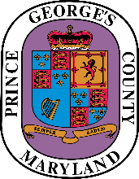
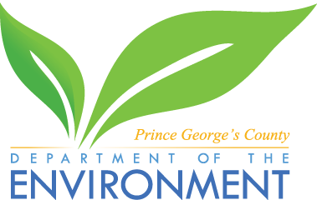
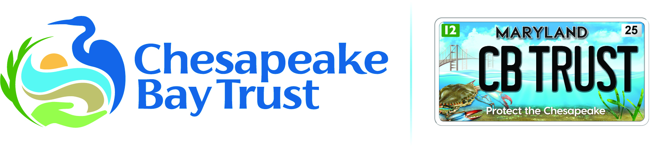

Prince George’s County Community Resilience Hub Grant Program
Narrative Questions
Instructions: Answer the following questions, then save and upload the completed document (your answers) as a Microsoft Word or PDF file into the online application form.
- Tell us more about your project: What are the big-picture goals and the specific objectives of the project? Why is this project needed and how was it identified? How will the success of your project support climate resilience in your target area? How does the project support Countywide planning (i.e., Plan 2035), equity, transportation, and economic development goals? How does the project support the County’s Climate Action Plan (CAP) and Climate Action Implementation Strategy Plan (CAISP)? [ANSWER HERE]

- Community Context: Identify the priority audience (e.g., neighbors, residents, businesses, etc.) engaged in this project and how you determined the need for the items requested. How will the services from this project be provided to the community members? How will the project benefit the community members?
Tell us how this project fits into other activities occurring in the community. For example, are neighboring facilities providing health services or homeowner’s associations who may already be undertaking climate resilience actions going to be engaged in this project? If so, describe how they will be engaged. [ANSWER HERE]
- Organizational Capacity: Please describe your organization’s capacity and experience to ensure that the proposed work will be successful. [ANSWER HERE]

- Partnerships: Will you partner with an organization to provide technical expertise? If you are partnering with another organization, tell us who they are and what support they are providing (either financial or other support). [ANSWER HERE]

- Demographic Information: In light of the Trust's commitment to the advancement of diversity in its award-making, provide demographic information about the community or population involved in or served by the project.
Provide your organization’s experience working within the specific communities that you will be prioritizing/engaging. If you have not had significant experience working with or as part of your prioritized audience, the Trust encourages applicants to establish partnerships with local organizations that may have greater cultural competencies within the prioritized demographic(s). Cultural competence involves understanding and appropriately responding to the unique combination of cultural variables which entails the integrated patterns of human behavior such as language, thoughts, actions, customs, beliefs, and institutions of racial, ethnic, social, or religious groups that the community or population bring to interactions. [ANSWER HERE]
- Contractors: We recommend getting at least three cost estimates or quotes from three service providers. Learn more at: FAQ-Document-for-Federal-Awards-1.12.2024.pdf (cbtrust.org).
- Has/will a contractor be hired and has a contractor been selected? (Yes/No)
- If you answered “Yes” that a contractor will be used: Describe your contractor/consultant selection process, including justification and background of the selected contractor/ consultant. [ANSWER HERE]

- Regulatory Issues: We are unable to fund projects that are required by a Federal, state, or locally issued permit, decree, mitigation, or enforcement action. In some cases, the Trust may elect to fund optional portions of required projects that go “above and beyond” the regulatory requirements.
Please answer yes or no to the following question: Is any part of your project is required under any existing or pending permit, decree, mitigation, and/or enforcement action? (Yes/No)
- Landownership: Do you own the land that the project is to occur on? (Yes/No)
  - If you answered “No” you must provide proof that the landowner approves the project. Learn more about letters of commitment here https://cbtrust.org/wp-content/uploads/Chesapeake-Bay-Trust-Letter-of-Commitment-Policy_072422.pdf.
- Sustainability: The funding partners aim to invest in projects that have the greatest potential longevity following the grant period. Several threats exist that may result in loss of project value: change in public interest in an effort; changes in rainfall or increases in flooding, droughts, and extreme heat associated with climate change; change in land use; and more.
Discuss the future you see for the work for which you are requesting funds. What factors may affect its long-term value and how will you ensure its long-term value is maximized? [ANSWER HERE]
- If the project needs ongoing ﬁnancial resources to maintain its value, provide an abbreviated plan describing how the project will be self-sustained beyond the term of the proposed funding request. [ANSWER HERE]
- If your organization is not a member of the community served by the project, how is transfer of project stewardship/ownership to the community built into the project? [ANSWER HERE]
- If proposing greening and/or capital improvement elements (e.g., tree planting or installation of equipment for capital improvement), you must provide a long-term maintenance plan (> 2 years). A simple plan template is available at: https://tinyurl.com/ebx4hs4b). For guidance on maintenance, see the Trust’s maintenance plan template and resources (https://cbtrust.org/additional-resources/) which include training videos. [ANSWER HERE]

- Evaluation: Describe how you will assess the effectiveness of your project. How will you collect information to refine and improve your project? [ANSWER HERE]

- For engagement, training, and/or outreach projects, how will you measure the number of people who increased their knowledge (e.g., pre- and post- surveys)? Provide a list of knowledge objectives or an evaluation plan to show beginning and end knowledge change. If you plan to hold a workshop, provide a draft agenda.
[ANSWER HERE IF CONDUCTING ENGAGEMENT, TRAINING, AND/OR OUTREACH ACTIVITIES]
- For on-the-ground, restoration projects (e.g., tree planting or community gardens) and/or structural projects (e.g., incorporating energy efficiency measures) tell us where your project is located, add photos, and if you do not own the land provide proof that the owner approves the project. If your project involves plants, provide the site plan with the native plant list and a maintenance plan. Tell us how you will determine if your project is working well.
[ANSWER HERE IF CONDUCTING RESTORATION ACTIVITIES]

