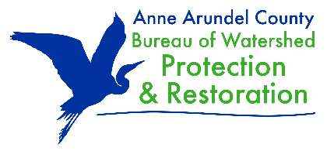



Appendix F: Best Management Practices Worksheet (Track 3 and 6)
A required Pre-Application Site Visit with the Trust and the County/City must be held prior to applying. It is strongly recommended that the project applicant organization, landowner, project designer, and any other relevant project partners attend the meeting. This worksheet should be filled out and submitted with your application.

1. What type(s) of project(s) are you planning? | 9. Have you met with any County or City entities regarding permitting?  CHECK: Yes ____ No ____ If YES, describe below:
  Bioretention Cell/Rain Gardens
  Stormwater Wetland
  Stream Restoration
  Step Pool Conveyance System (SPSC)
  Living Shoreline
  Green Roof
  Other (detail in #2)
2. If Other (in #1), provide additional detail: | 10. Provide additional detail regarding permit status and a list of required permits applicable to your project:
3. What size project(s) are you planning? | 11. List relevant or potential partnerships for this project:
  Small restoration projects with a disturbance footprint of less than 5,000 square feet or less than 100 cubic yards of soil
  Large restoration projects with a disturbance footprint greater than 5,000 square feet or more than 100 cubic yards of soil
4. Have you read the RFP?
CHECK: Yes ____ No ____

5. Could the project be designed to be implemented in distinct phases?
CHECK: Yes ____ No ____
12. A completed drainage area data table for each Best Management Practice (BMP) will be required. Populate the table below (and if necessary), create additional tables for each BMP.
Type of BMP Proposed:
Total Drainage Area to BMP (in acres):

Impervious Area draining to BMP (in acres):

As applicable, record Field Notes for BMPs here:

6. Who owns the land on which the project will be located?

7. Is the landowner(s) willing to sign a Memorandum of Understanding (MOU) with the County or a Maintenance Agreement with the City?
CHECK: Yes ____ No ____

8. How complete are your design plans?
30% complete
60% complete
90% complete
100% complete
Other or NA (describe below):

