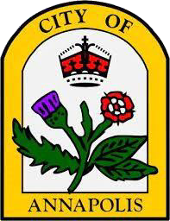
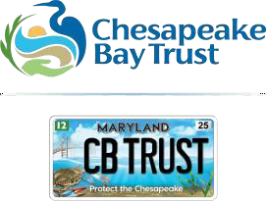
CITY OF ANNAPOLIS ELECTRIC LEAF BLOWER REBATE PROGRAM

Appendix A – Application Process

- Verify eligibility. Check to make sure you're located in the incorporated City of Annapolis limits by using our address check map:
https://www.google.com/maps/d/viewer?mid=1LtdUwoGzeA6oIRe0ilaasz0RINWwS b4&ll=38.97012438124843%2C-76.49840285857843&z=14.
- Review Project Guidelines:
  - Review the City of Annapolis Electric Leaf Blower Rebate Program Application Instructions which can be found at https://cbtrust.org/grants/annapolis-leaf-blower-rebate/ before purchasing leaf blower. Purchases must meet the criteria outlined to receive a rebate.
- Purchase electric leaf blower.
  - Please ensure that the leaf blower emits sound less than or equal to 65 dB and meets all other program guidelines.
- Fill Out and Submit an Application:
  - To apply online (recommended), please review the Online Application Submission Instructions below.
  - To apply via paper application, download the application form at https://cbtrust.org/grants/annapolis-leaf-blower-rebate/ or contact us to get a copy mailed to you. Completed paper application forms should be mailed to the following address:
City of Annapolis Electric Leaf Blower Financial Assistance Program Chesapeake Bay Trust
108 Severn Avenue
Annapolis, MD 21403
- Trust Reviews Application.
  - Please expect about 2 weeks for the Trust to review your application and supporting documentation. They will reach out if any other information is needed.
- Receive Rebate Approval
  - The rebate check will arrive via mail at the mailing address included in your application.

Online Application Submission Instructions
The Trust has transitioned to a new award management system, SmartSimple!
To begin an application, please go to https://cbtrust.org/grants/community-engagement/ and click on “Get Started.” This will take you to the SmartSimple portal, where you can log in or create an account.
If you have received an award from the Trust previously, your profile will be set up in SmartSimple. To access it please enter the same email you used in our former system (Blackbaud), then click ‘forgot password’, and follow the prompts to create a new password.
If you are new to the Trust, please click on the blue “Register” button on the login screen.
Once logged in, navigate to “Funding Opportunities” and select the grant program you would like to apply for. See https://cbtrust.org/login for help setting up your account and finding funding opportunities.
At the start of the online application form, you will be asked to complete an eligibility
review which is meant to assist you in determining if your project meets the requirements of this program. You will then be asked to provide the following information. Complete the application to the best of your ability.
- Applicant and Project Information Tab
  - Provide the applicant’s name, mailing address, phone, email address, and applicant type. The applicant must be a Single-family (including townhomes) property owner, renter, nonprofit (including religious institutions, private
schools, homeowners associations (HOA) and condominium associations), landscape contractor, or lawncare business within the Incorporated City of Annapolis limits.
  - Provide the property information including the property address. For
landscape contractors, provide the organization or business name and the tax ID number.
  - Provide project information including the project goals
- Supporting Documents Tab
  - Upload all required supporting documents – see below for a checklist

Proof of Residence (Only required for renter – submit a bill or rental agreement
that has your full name and address)
Paid Receipts/Invoices
- For residents: Receipts/Invoices must show that the leaf blower was shipped to or
purchased within the state of Maryland
Proof of Work in the City
- For lawncare servicers and landscape contractors: Please include an invoice or other proof of work that shows you have worked within the City limits within the last year.

