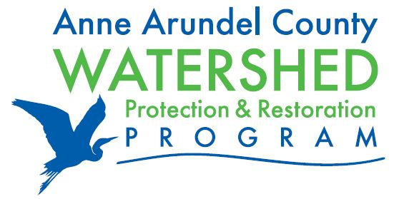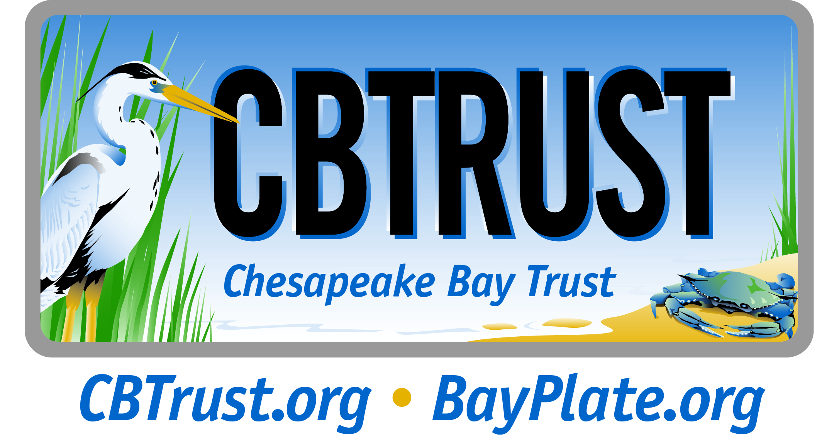

Chesapeake Bay Trust: Molly Alton Mullins 410-271-3469 mmullins@cbtrust.org
Anne Arundel County: Matt Diehl 410-222-7582, pwdieh00@aacounty.org

New Watershed Restoration Grant Program Announced in Anne Arundel County

(Annapolis, MD) December 8, 2014 –The Anne Arundel County Department of Public Works and the Chesapeake Bay Trust announce a new grant program, the Watershed Restoration Grant Program, to support restoration activities throughout Anne Arundel County to improve water quality in local streams and rivers. The grant program was created to engage local nonprofit organizations, landowners, and communities in efforts to restore the County’s waterways; to provide resources to these groups to enable them to implement greening and water quality projects; and to assist Anne Arundel County’s efforts to meet the requirements of its state and federal stormwater pollution permit and local waterway cleanup plan. This program encourages on-the-ground restoration activities that reduce storm flow and pollutants and engage Anne Arundel County residents in these activities.

“Anne Arundel County is undertaking extensive on-the-ground efforts to do our part to help restore the Chesapeake Bay and its rivers and streams,” said Erik Michelsen, administrator of Anne Arundel County’s Watershed Protection and Restoration Program. “We recognize that restoring our waterways takes teamwork and this grant program is an opportunity for the County to partner with local organizations to have a positive impact on our creeks, streams and rivers. We look forward to working with County residents and the Chesapeake Bay Trust as we all do our part to restore and protect our waterways.”

The Anne Arundel County Watershed Restoration Grant Program will fund projects that reduce pollutants through the implementation of watershed restoration practices. Specifically, the program supports implementation requests for: bioretention cells, bioswales, rain gardens, and other low impact development stormwater techniques; stormwater wetland and marsh creation and enhancement; stream and wetland restoration practices of various types; and green roofs. Other project ideas will be considered on a case by case basis and all applications will be reviewed by an independent peer review Technical Review Committee.

“The Chesapeake Bay Trust provides hundreds of grants each year to nonprofit organizations, homeowners associations, community groups, watershed groups, schools, faith-based organizations, and more to facilitate their efforts to improve water quality, manage stormwater runoff, and create local stewards, “said Jana Davis, executive director of the Chesapeake Bay Trust. “These groups are valuable partners in the community effort to restore our waterways, and this partnership with the County will allow us to expand our grantmaking and these nonprofit groups’ ability to make an impact in decreasing polluted runoff in their neighborhoods and ultimately in our streams, rivers, and the Chesapeake Bay.”

Grants requests between $20,000-$100,000 will be accepted online until February 27 at 5:00 pm. Projects must be implemented in Anne Arundel County, and applications must include at least one partner that represents a stakeholder group based in the County. Funding partners welcome requests from 501(c) non-profit organizations: including watershed groups; community associations; service, youth and civic groups; and faith-based organizations. For more detailed information and to access the full Request for Proposals, visit www.cbtrust.org/grants/AnneArundelWR.

# # #

About Anne Arundel County Watershed Protection & Restoration Program
The Watershed Protection and Restoration Program, part of the Anne Arundel County Department of Public Works, is responsible for carrying out the County’s stormwater restoration strategies to improve local water quality and ensure it meets both federal and state water quality requirements. For more information about the WPRP visit www.aarivers.org.

About the Chesapeake Bay Trust

The Chesapeake Bay Trust is a nonprofit, grant-making organization dedicated to improving the Chesapeake Bay and its rivers through environmental education, community outreach, and local watershed restoration. Since 1985, the Trust has awarded $65 million in grants and engaged hundreds of thousands of citizen stewards in projects that have a measurable impact on the Chesapeake Bay and its tributaries. The Trust is supported by the sale of the Maryland Treasure the Chesapeake license plate, donations to the Chesapeake Bay and Endangered Species Fund on the Maryland State income tax form, donations from individuals and corporations, and partnerships with private foundations and federal and state agencies.

