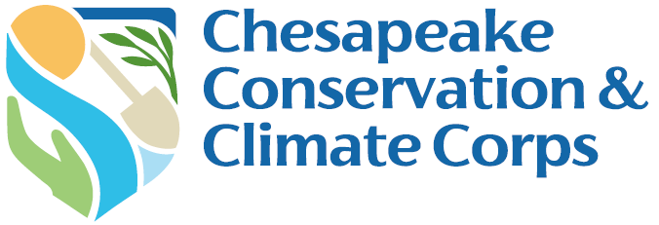

Host Organization Final Report Form

Due: August 8, 2025

Complete the final report narrative questions below. After completing your narrative questions, save this document on your computer, and then submit the document via your Chesapeake Bay Trust Online account. You can access your account using this link https://www.GrantRequest.com/SID_1520.

1. Host Organization Mentor Information

Host Organization:
Mentor Name:
Corps Member Name:

2. Tracking Progress
- Please have a meeting with your Corps Member to review and refine your Work Plan and update the Status Column. Once complete, provide a shareable link below (click on the blue Share button in the upper right corner and then click Copy Link in the Get a Link section).

Final Work Plan Link:

3. Work Plan & Capstone Projects
- Based on the goal outcomes you and your Corps Member identified at the start of the Corps program, would you consider their Work Plan projects overall as successful?

- What do you think was your Corps Member’s biggest Work Plan project win? What do you think was their biggest Work Plan project challenge?

- Based on the goal outcomes you and your Corps Member identified at the start of the project, would you consider their Capstone a success?

- What do you think was your Corps Member’s biggest Capstone Project win? What do you think was their Capstone Project challenge?

4. Program Evaluation
Member & Mentor Experience
- What do you consider to be you and your Corps Member’s greatest success during the program? Why do you consider this to be a significant success?

- What do you consider to be you and your Corps Member’s greatest challenge during the program? How did you address the challenge?

- What do you consider to be your Corps Member’s most significant area of growth over the course of the program?

- What advice would you give your Corps Member as they move on from the program?

- What advice would you give future Host Organizations Mentors?

Program Elements
- What do you think is the best element or aspect of the Corps program?

- What program element or aspect of the Corps program needs the most improvement or should be removed?

- Were the Corps Mentor Workshops beneficial to your Corps experience? What was your largest takeaway from the workshops? Are there additional topics you think the mentor workshops should cover?

Feedback for the Trust
- What advice would you provide the Trust to improve the program?

- What additional support is needed for Corps Members and/or Mentors?

- Would you recommend the Corps to others? Would you host another Corps Member in the future?

Please upload and/or send the Trust (HRost@cbtrust.org) photos of your Corps Member’s experience as well as any products they have created, blogs they have written, or news articles that mention them or their work.

You are required to submit this report online. Directions for submitting online:
- After completing your narrative questions, save this document on your computer and then submit the document via your Chesapeake Bay Trust Online account.
- Sign into your account using this link https://www.GrantRequest.com/SID_1520 and the same username and password as when you applied.
- Once signed in click on the Requirements tab.
- If you do not see your requirement, use the dropdown on the right and in the middle of the page to shift between “Show: New” and “Show: In Progress”.
- You should see below the yellow bar your Status Report link.
- Click on the Status Report link and follow the instructions.
- Once complete, click Submit & Review and make sure you have uploaded and entered all of the necessary information.
- If so, click Submit.

To confirm your requirement was successfully submitted use the dropdown to shift between “Show: In Progress” and “Show: Submitted Requirements”.

DISCLAIMER: By submitting photos and videos in your report, you are acknowledging ownership and copyright of the photos and videos submitted. The copyright will remain with the photographer; however, the Trust reserves the right to publish all items in publications, websites, advertising and promotional materials. You also confirm that you have written consent from all subjects in the photos/video submitted including if any subjects are minors under the age of eighteen.

