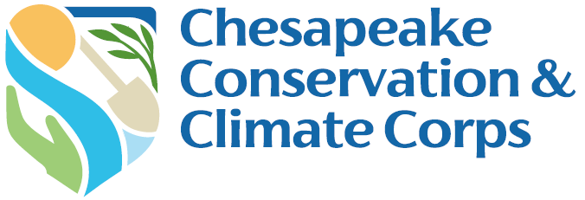

Host Organization Status Report Form

Due: December 1, 2025 & April 1, 2026

Complete the status report narrative questions below. After completing your narrative questions, save this document on your computer, and then submit the document via your Chesapeake Bay Trust Online account. You can access your account using this link https://www.GrantRequest.com/SID_1520.

1. Host Organization Mentor Information

Host Organization Name:
Mentor Name:
Corps Member Name:
Reporting Date:

2. Tracking Progress
Please hold a meeting with your Corps Member to review and refine the Work Plan and update the Status Column. Once complete, provide a shareable link below (click on the blue Share button in the upper right corner and then click Copy Link in the Get a Link section).

Updated Work Plan Link:

3. Program Evaluation

- Describe the greatest success and biggest challenge you and your Corps Member experienced this reporting period. Why did you identify this as your greatest success? What is your plan to address the challenge?

- Is your Corps Member meeting you/your organization’s expectations? If not, what is your plan to address any challenges?

- Is the program progressing as anticipated? If not, what mid-course corrections do you think could be applied, if any?

- Is there any additional support the Trust can provide at this time? If so, please describe. Be honest, this information will be kept confidential unless you tell us otherwise. Remember we want, and are here, to help!

Please upload and/or send the Trust (HRost@cbtrust.org) photos of your Corps Member’s experience as well as any products they have created, blogs they have written, or news articles that mention them or their work.

You are required to submit this report online. Directions for submitting online:
- After completing your narrative questions, save this document on your computer and then submit the document via your Chesapeake Bay Trust Online account.
- Sign into your account using this link https://www.GrantRequest.com/SID_1520 and the same username and password as when you applied.
- Once signed in click on the Requirements tab.
- If you do not see your requirement, use the dropdown on the right and in the middle of the page to shift between “Show: New” and “Show: In Progress”.
- You should see below the yellow bar your Status Report link.
- Click on the Status Report link and follow the instructions.
- Once complete, click Submit & Review and make sure you have uploaded and entered all of the necessary information.
- If so, click Submit.

To confirm your requirement was successfully submitted use the dropdown to shift between “Show: In Progress” and “Show: Submitted Requirements”.

DISCLAIMER: By submitting photos and videos in your report, you are acknowledging ownership and copyright of the photos and videos submitted. The copyright will remain with the photographer; however, the Trust reserves the right to publish all items in publications, websites, advertising and promotional materials. You also confirm that you have written consent from all subjects in the photos/video submitted including if any subjects are minors under the age of eighteen.

