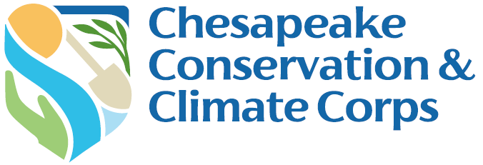

Corps Member Status Report Form

Due: December 1, 2025 & March 1, 2026

Complete the status report narrative questions below. After completing your narrative questions, save this document on your computer, and then submit the document via your Chesapeake Bay Trust Online account. You can access your account using this link https://www.GrantRequest.com/SID_1520.

1. Corps Member Information

Host Organization Name:
Mentor Name:
Corps Member Name:
Reporting Date:

2. Tracking Progress
- Please have a meeting with your Mentor to review and refine your Work Plan and update the Status Column. Once complete, provide a shareable link below (click on the blue Share button in the upper right corner and then click Copy Link in the Get a Link section).

Updated Work Plan Link:

3. Update on Work Plan Activities
- What projects or tasks on your work plan have you made notable progress on?

- Are certain projects or tasks on your Work Plan not being tackled as scheduled? If so, why?

- Are there any tasks you worked on this quarter that are not listed on your work plan? If so, please summarize these additional activities.

4. Update on Capstone Project Activities
- What progress have you made on your Capstone Project this quarter?

- What has been your biggest Capstone Project ‘win’ this quarter?

- What has been your biggest Capstone Project hurdle this quarter and what is your plan to address the challenge?

- In terms of timeline, are you on track? If not, what is causing the delay and what is your plan to address the delay?

5. Peer-to-Peer Site Visits
Please list the Name and Organization of any Corps Members you have visited this quarter:

Name | Host Organization | Date | Activities conducted
1.
2.
3.
4.

Please list the Name and Organization of any Corps Members who visited you this quarter.

Name | Host Organization | Date | Activities conducted
1.
2.
3.
4.

6. Program Evaluation
- What do you consider to be your greatest overall success this reporting period? Why do you consider it your greatest success?

- What do you consider to be your biggest overall challenge this reporting period? What is your plan to address the challenge?

- Do your Mentor and Host Organization meet your expectations?

- Is the program progressing as anticipated? If not, what mid-course corrections do you think could be applied, if any?

- Is there any additional support the Trust can provide to help with your work plan projects, capstone, mentor, host organization, and/or overall Corps experience? If so, please describe. Be honest, this information will be kept confidential unless you tell us otherwise. Remember we want, and are here, to help!

Please upload and/or send the Trust (HRost@cbtrust.org) photos from your Corps experience as well as any products you have created, blogs you have written, or news articles that mention you or your work.

You are required to submit this report online. Directions for submitting online:
- After completing your narrative questions, save this document on your computer and then submit the document via your Chesapeake Bay Trust Online account.
- Sign into your account using this link https://www.GrantRequest.com/SID_1520 and the same username and password as when you applied.
- Once signed in click on the Requirements tab.
- If you do not see your requirement, use the dropdown on the right and in the middle of the page to shift between “Show: New” and “Show: In Progress”.
- You should see below the yellow bar your Status Report link.
- Click on the Status Report link and follow the instructions.
- Once complete, click Submit & Review and make sure you have uploaded and entered all of the necessary information.
- If so, click Submit.

To confirm your requirement was successfully submitted use the dropdown to shift between “Show: In Progress” and “Show: Submitted Requirements”.

DISCLAIMER: By submitting photos and videos in your report, you are acknowledging ownership and copyright of the photos and videos submitted. The copyright will remain with the photographer; however, the Trust reserves the right to publish all items in publications, websites, advertising and promotional materials. You also confirm that you have written consent from all subjects in the photos/video submitted including if any subjects are minors under the age of eighteen.

