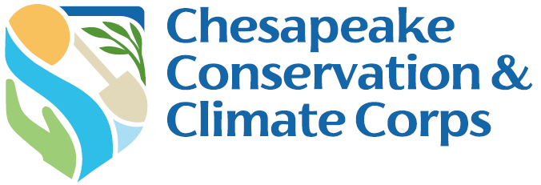

Capstone Abstract Form

Due: December 1, 2026

Complete the Capstone Project Abstract form and submit through the Capstone Abstract Requirement available in your Chesapeake Bay Trust’s Online Account https://chesapeakebaytrust.us-1.smartsimple.com/s_Login.jsp.

1. Corps Member Information

Host Organization Name:
Mentor Name:
Corps Member Name:
Capstone Title:

2. Abstract
Please provide a brief (1 sentence) high-level description of your project idea.

3. Abstract Description
Provide a detailed description (2-3 paragraphs) of your Capstone Project goals, necessary background or context, who will benefit from your project, and how your project will be sustainable and/or have an impact after the Corps term.

4. Timeline
Brief outline of the steps that need to be accomplished with estimated deadlines for your Capstone to be successful and completed before your Corps term.

Start Date | Deadline | Action

4. List of Partners (if applicable)

5. Estimated Project Cost
With funding sources if known.

6. Project Outcomes: What does success look like?
You’re walking away in August… what does a successful Capstone project look like? What benefits and/or changes are you hoping will result from your project?

7. Evaluation Plan
What processes will you undertake to analyze progress toward your goals and measure success?

You are required to submit this report online. Directions for submitting online:
- After completing your narrative questions, save this document on your computer and then submit the document via your Chesapeake Bay Trust Online account.
- Sign into your account using this link https://chesapeakebaytrust.us-1.smartsimple.com/s_Login.jsp and the same username and password as when you applied.
- Once signed in click on the Reports & Contingencies tab.
- Click on the Capstone Contingency and follow the instructions.

DISCLAIMER: By submitting photos and videos in your report, you are acknowledging ownership and copyright of the photos and videos submitted. The copyright will remain with the photographer; however, the Trust reserves the right to publish all items in publications, websites, advertising and promotional materials. You also confirm that you have written consent from all subjects in the photos/video submitted including if any subjects are minors under the age of eighteen.

